3 Concorde Gate, Suite 302, Toronto, Ontario, M3C 3N7
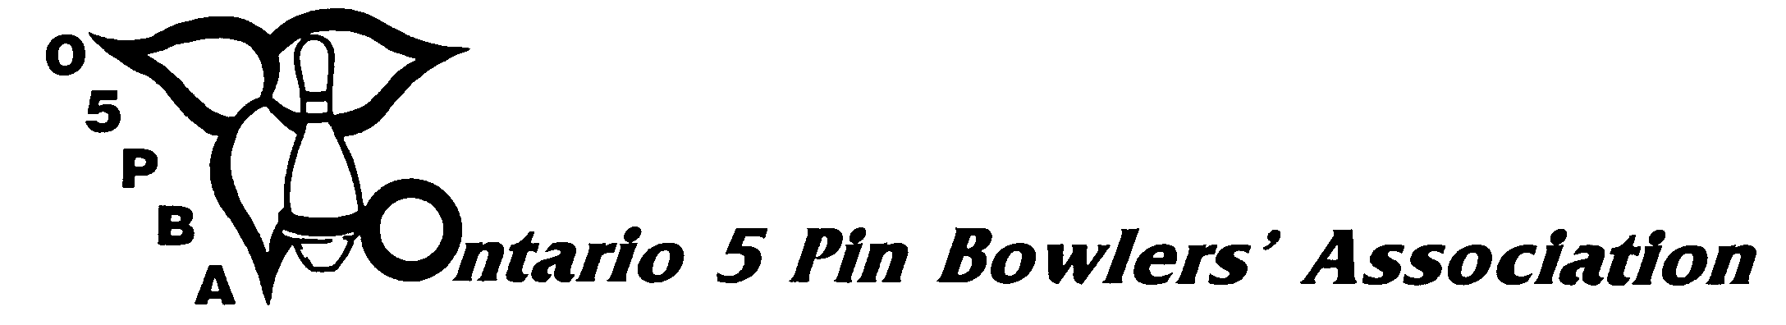
Telephone: (416) 426-7167 Fax: (416) 426-7364 E-Mail: o5pba@o5pba.ca Website: www.o5pba.ca

DECLARATION OF INTENT – BOWLERS/COACHES
TOURNAMENT DIRECTOR REPORT FORM

The information requested on this form must be received in the Provincial Office on or before NOVEMBER 3, 2013 in order for the Provincial Office to prepare a Master List for all Zone Association Tournament Directors.

ZONE ASSOCIATION:

TOURNAMENT DIRECTOR:

DATE OF REPORT:

Our Association is submitting a “NIL” reply meaning we have not received “Declaration of Intent” Forms for any bowlers/coaches.

The following individuals have submitted the proper paperwork declaring that they wish to be considered a bowler and/or coach from our Association for the Provincial Open Championships.

NAME OF BOWLER | RESIDENCY ZONE
NAME OF BOWLER | RESIDENCY ZONE

NAME OF COACH | RESIDENCY ZONE

